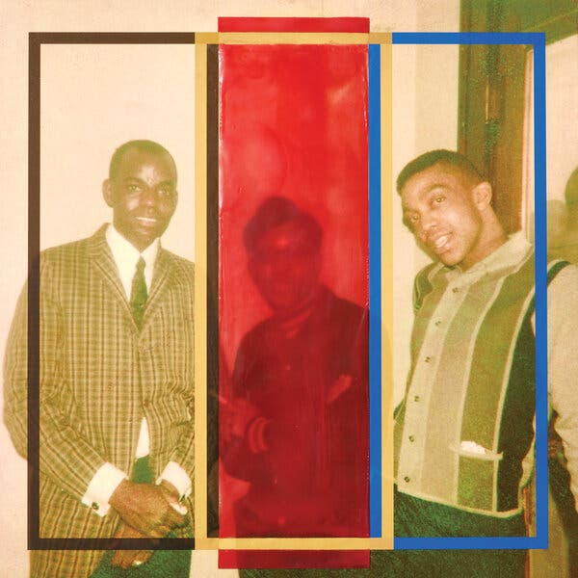

For the essays in this issue, we commissioned and chose works about friendship; the images are not meant as literal reflections of the text. Above is “In Memory of a Sure Thing” (2021), made exclusively for T by the New York-based artist Alanna Fields. Photo by Joshua Scott

LONG-DISTANCE FRIENDS

**The Composer of Noise**

A look back at one of those relationships where, despite changes in circumstance and place, two people are able to pick up where they left off.

By Cathy Park Hong

April 12, 2021

I MET REI at an artists’ residency in the late 2000s, when the New England landscape was at its greenest and most vertiginous. At dusk, wood thrushes chimed their watery, ethereal songs, which I now associate with freedom and creative ferment. I recall Rei entering the screened-in porch where a few residents were smoking and introducing himself as a composer from Japan. He was 32, about the same age I was at the time, and wore a baggy black hoodie, trousers and thick, white-framed glasses. He kept his hair longer in the front so that a thicket of bangs swept just past his left eyebrow. He was tall, and if you looked closely, he was attractive. But it was hard to notice that because he was quiet and looked as if he wanted to shrink into himself, like a teenage boy who’d shot up over the span of the summer.

Also in residence was a petite and impish artist from Korea whose sense of humor turned aggressive when she drank and Rei happened to be within her vicinity. At parties or when we gathered in the common room late at night, she hunted him down to antagonize him with her daily recriminations, which I presume was her way of flirting.

“If it’s not the imperialist,” she would say.

“Hello, Bangul,” Rei would say.

“Your people tortured us, taking away our language, our names, even.”

“Yes, I know.”

“And to this day, you still refuse to apologize.”

“But I did, just yesterday.”

“Is your father rich? How else could you be here in America, studying to be a composer? What does he do?”

“He’s the C.E.O. of Sony.”

“Are you telling the truth?” Bangul shouted excitedly. “You’re lying!”

Rei accepted her nightly censures with equanimity, but when he grew tired of them, he nudged her away with ironic deflections that only inflamed her further. Since I’m Korean, too, I was amused by her antics but watched without joining in. I didn’t pay much attention to Rei at first because of his laconic nature. But he had a depth of character that kept uncupping itself like nesting dolls the more I talked to him. He was wry, analytical, but also affectionate and without judgment. We ended up becoming close rather quickly, which is not unusual in residencies, where friendships are fast-tracked.

REI, WHOM I’VE identified by his middle name, was not the scion of Sony but the son of flower farmers in a rural working-class town north of Tokyo. His hometown was stifling and homogeneous, and as soon as he was able — once he turned 19 — he escaped. After the tsunami hit Japan in 2011 and led to the nuclear meltdown in [Fukushima](https://www.nytimes.com/2021/03/10/world/asia/fukushima-japan-nuclear-anniversary.html), I emailed him to ask about his family. He responded, saying that his parents lived 100 miles from the nuclear plant, a safe enough distance away.

Since then, I’d lost contact with Rei, but thought of him recently while reading “[Ghosts of the Tsunami](https://us.macmillan.com/books/9781250192813)” by Richard Lloyd Parry, which is about the grieving parents of children who were swept away by the wave while they were at school. Unyielding fealty to bureaucracy killed these students as much as the tsunami itself, because their teachers, adhering to instructions in a poorly worded emergency manual, neglected to evacuate them to higher ground despite frantic warnings from others that a flood was coming. After I read the book, I searched for our last correspondence and found, to my dismay, that I had misread Rei’s email all those years ago. He’d written, “My parents live 100 miles away from the power plant, not far enough away to be optimistic. We’ll see how it develops.”

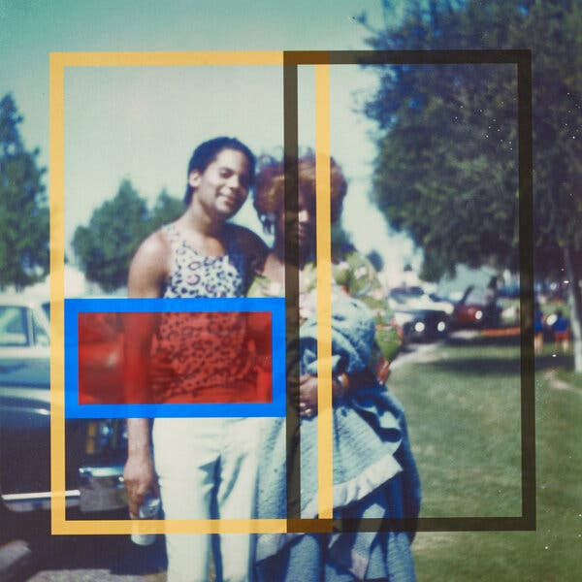

TO WRITE ABOUT friendship is an exercise in nostalgia, one that more often draws a portrait of your former self than a portrait of the friend, especially during a pandemic, when I’m prone to dwelling on what is absent from my life. Without the varying textures of experience, days are deleted from my life. I age meaninglessly. My interest in writing about Rei might therefore be suspect: Is it our friendship I’m interested in? Or is he a portal to those years when I felt the least burdened by responsibilities, when I could roam as I pleased and see whom I wanted?

After the residency, we met intermittently, since we lived on separate coasts, and then, later, in separate countries. I was in New York, while he resided in Los Angeles, getting his Ph.D. in computer music. He rented an apartment in Koreatown, chosen for its central location, since he was the only person I knew in L.A. who didn’t own a car. He took the bus, or odder still, he walked.

When I visited my family in L.A., which is where I grew up, I saw him, too. I picked him up and took him for a drink at a landmark restaurant that once appeared in the film “Chinatown,” and which, with its red leather banquettes and ruby crushed-velvet lamps, had the trappings of Old Hollywood, except it was now owned by Koreans who, alongside martinis, served plates of spicy octopus and kimchi fried rice. We always met as visitors from elsewhere, in settings that held no connection to our past. Even the bar, despite being in my hometown, was like a midcentury film set that had nothing to do with my youth.

Of course, our respective histories remained in the background like a mountain of ash. Sometimes I reached back to grab a handful to throw at him. Like Bangul, I couldn’t help it. I joked that he owed me a lifetime of cocktails for the 35 years during which Korea had been a Japanese colony. But except for my occasional quips, we were free of rivalry, or pettiness, or nascent sexual desires. And perhaps this is why I return to Rei, because I felt in our companionship a rare harmony.

WE TALKED ABOUT love, mostly. As a teenager, I used to promise my father, almost on a weekly basis, that I would marry a Korean man, while inwardly knowing that no man of my tribe would want me. I wasn’t feminine enough; I was too odd. With each promise I made, a suffocating, palpitating panic spread from my heart to my throat to my eyes, until I saw only the burning, spidery spots that you see after looking directly at the sun. Bound to break this promise, I felt I would always live alone, a fate that seemed all the more imminent throughout my 20s, when I actually did fall in love with several Asian men, all of whom broke my heart.

Rei had similar pressures from his parents, who expected him to take over the family farm, marry and have children. But by the age of 10, he already knew he wanted nothing to do with flowers or his hometown. He’d level out at just over six feet by adulthood, but as a boy, he stood out for his extraordinary height. He was the tallest boy in class, but he didn’t know how to wield his height to his advantage, as if it were a sword too heavy to lift. Sensing his defenselessness, the boys bullied him, especially since he refused to play his part in the pecking order, where the oldest and strongest hazed the youngest without mercy. Eventually, Rei left, moving first to Tokyo for college, and then to Chicago, Rotterdam, Los Angeles and finally to Berlin, where he settled. He took shelter in graduate programs that subsidized his music, which was alchemized from computer algorithms, music that was so shatteringly dissonant, it seemed almost a revolt against his agrarian origins.

Both of us were certain that we’d always be alone, but it turned out for nought. By the time I met Rei, I was dating someone who would become my husband. Rei would eventually meet someone, too, but at the time, he was single. He seemed self-sufficient in his solitary life, as if a partner would interfere with his studies, so I was surprised to learn that he’d once been engaged to a Japanese woman who lived with him when he was in the Netherlands. It was out of obligation to her father, who demanded they marry if they lived together abroad but, inevitably, it didn’t work out. He left, drifting away to California.

Image

He told me about his hapless dates that he didn’t know were dates until afterward. “I don’t have any luck with women,” he said, shrugging his shoulders, appearing not entirely anguished by his bad luck. He had a subtle Japanese accent and laughed easily at my jokes, which flattered me because he didn’t laugh easily at anyone else’s. When we met up, the boundaries between our selves dissolved, while our individualities were at their most articulated — and maybe, too, there was a buried chord of desire that made it especially pleasurable to see him. I introduced him to my sister, hoping they would hit it off. How perfect would that be: two people for whom I had a deep, abiding affection, together. Instead, having been awarded a yearlong fellowship, he left for Berlin.

WHILE READING “GHOSTS of the Tsunami,” I searched online for footage of the disaster, expecting it to sound like the hurricanes I’d watched on CNN, with howling winds and lashing water, or the oceanic roar of pounding waves. But it wasn’t what I expected at all. It was a malevolent thing, a black, flat, fast-moving amoebal mass, efficiently swallowing acres of gray paddy fields, office buildings, tile-roofed homes and highways full of cars. But what I heard was even eerier because the tsunami sounded so animal-like, like it was digesting all of human civilization, with its peristaltic, grinding crunch of steel and concrete and whole forests being ripped from their roots.

Thinking back, it was that sound, rather than the book, that first reminded me of Rei after all these years. It recalled for me his music, which I first encountered at the residency. We’d gathered at a library that was once a stone chapel and sat on foldout chairs. He turned off the lights and began his composition. A wind rose to a high jet whine that amplified to an annihilating engine roar. With no visuals or lyrics to help guide me, my imagination ran through a gauntlet of disasters. An artist from New Orleans cried afterward, saying she’d pictured a hurricane. Later, Rei told me he wanted to create a shelter of sound with his compositions. But at the time, I felt the opposite, as if his music had simulated a great suctioning cavity where there was once shelter, as if the chapel had been ripped from its foundations and we were exposed to the fury of a godless earth for the wounds we inflicted upon it.

IN THE MIDST of writing this piece, I reconnected with Rei over Zoom to ask about his parents. He lives in Berlin with two kids and his partner. He told me that his parents were doing fine, although some still believe that the poisons that had seeped into the earth might resurface later in the genes of plants, or animals, or children. When I told him that I was writing an essay about him, he was amused but also puzzled. But what could I possibly say?

The last time I saw Rei was in 2010, when my husband and I spent the summer in Berlin, a city that, with its graffiti and D.I.Y. gardens, still looked as though it had been rebuilt by artists. Rei and I hung out quite often that summer, meeting up for drinks at beer gardens or dinner along the green canal in Kreuzberg. I felt so weightless then.

Maybe I’m craving a similar sense of peace during these isolating, anxious days, not unlike the relieved peace of seeing a friend in a foreign country and being able to speak fluently to them. I want to say that the levity with Rei felt hard won, a light cast against what came before us generations ago, when Japan first imposed upon Korea a brutal police state. But I wonder if such a connection can even be made between then and our friendship now, or if I’m contriving it to appease in me some compulsion for closure.

Toward the end of my stay, Rei told me he’d met a German woman, who would later become his partner.

“We are moving in together,” he said.

“Already?”

“My lease is up, and she offered her flat,” he said, looking embarrassed. “She even put down her cat because I’m allergic.”

“Wow — *that* is love.”

“I told her it wasn’t necessary.”

“Also *very* German.”

“She’s actually nice. Do you want to meet her?”

I couldn’t resist some other crack about the Axis powers reuniting. I felt protective, like a sister, even a little jealous. But he looked happy, so I reassured him that I was happy for him. It was mid-August, and already there was a chill to the breeze, which tinged me with anxiety about returning home and a future that felt uncertain. He said he’d miss me and wondered when we’d see each other again. “I’ll visit next summer,” I said. “As soon as I’m free.”